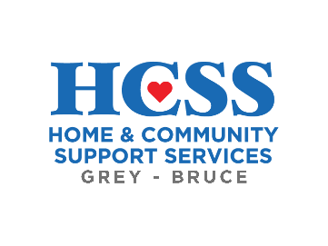
FOR IMMEDIATE RELEASE

OCTOBER IS COMMUNITY SUPPORT MONTH

HCSS Grey-Bruce celebrates the staff and volunteers helping seniors and adults-living-with-disabilities stay healthy at home.

Grey & Bruce Coutnies, October 1, 2023 – This October, join Home & Community Support Services Grey-Bruce as we celebrate Community Support Month, a time to raise awareness about the wide-ranging and invaluable services available to help vulnerable Ontarians stay healthy at home.
Community support organizations like HCSS Grey-Bruce have deep roots within the community and we are committed to providing care for seniors and adults-living-with-disabilities.
Our services include:
- Transportation
- Hot & Frozen Meals on Wheels
- Day Away
- Overnight Respite
- Housekeeping
- and Friendly Visiting.
There are Community Support Service providers in almost every community across the province, many of them delivered by committed staff and volunteers. Collectively, volunteers donate close to 3 million hours of service each year.

HCSS Grey-Bruce has been providing care in the community for 30 years. Our services provide a lifeline for vulnerable seniors urban and rural alike. As more Canadians are facing financial strain, food insecurity, and rural Canadian struggle with transportation and isolation we are proud to be able to help as much as we can.
We are proud to recognize Community Support Month 2023 by sharing our stories and information on our social media to increase public awareness of what community support services are and why they are an integral part of the healthcare system – especially now.
Everyone across Grey-Bruce is invited to celebrate with a follow on Facebook and Instagram at @HCSSGreyBruce.

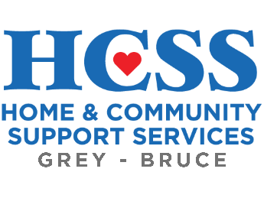 | About HCSS Grey-Bruce: Home and Community Support Services of Grey-Bruce is a team of caring staff and volunteers who provide community-based services that support independence and enhance the quality of daily life for seniors, adults, and their families. Programs include Transportation, Hot and Frozen Meals on Wheels, Day Away and Overnight Respite Care, Housekeeping, and Friendly Visiting. The programs and services offered are only partially funded by the provincial government. Community support through volunteering and donations keep these much-needed services available across Grey and Bruce counties.
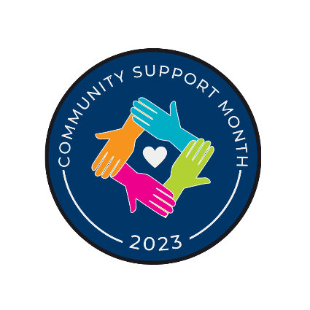 | About Community Support Month: Home and community support services support over one million Ontarians each year, including seniors and people with disabilities. October is Community Support Month, an opportunity to celebrate and raise awareness about the value of these services. Not-for-profit home and community care programs only receive partial government funding, and are supported by community foundations, individual donations, and thousands of dedicated volunteers. With celebration days like “Community Care Worker Week” and “Attendant Services Day,” the month recognizes the hard work these frontline workers do for our community, while increasing public awareness of what community support services are and why they are an integral part of the healthcare system.  For more information, visit www.ocsa.on.ca.

-30-

To arrange an interview or for more information, please contact:

Stephen Musehl
Executive Director
Home & Community Support Service Grey-Bruce
519-372-2091 ext. 2025
smusehl@hcssgreybruce.com

Rachel Taylor
Community Development & Philanthropy Coordinator
Home & Community Support Service Grey-Bruce
519-372-2091 ext. 2014
rtaylor@hcssgreybruce.com

